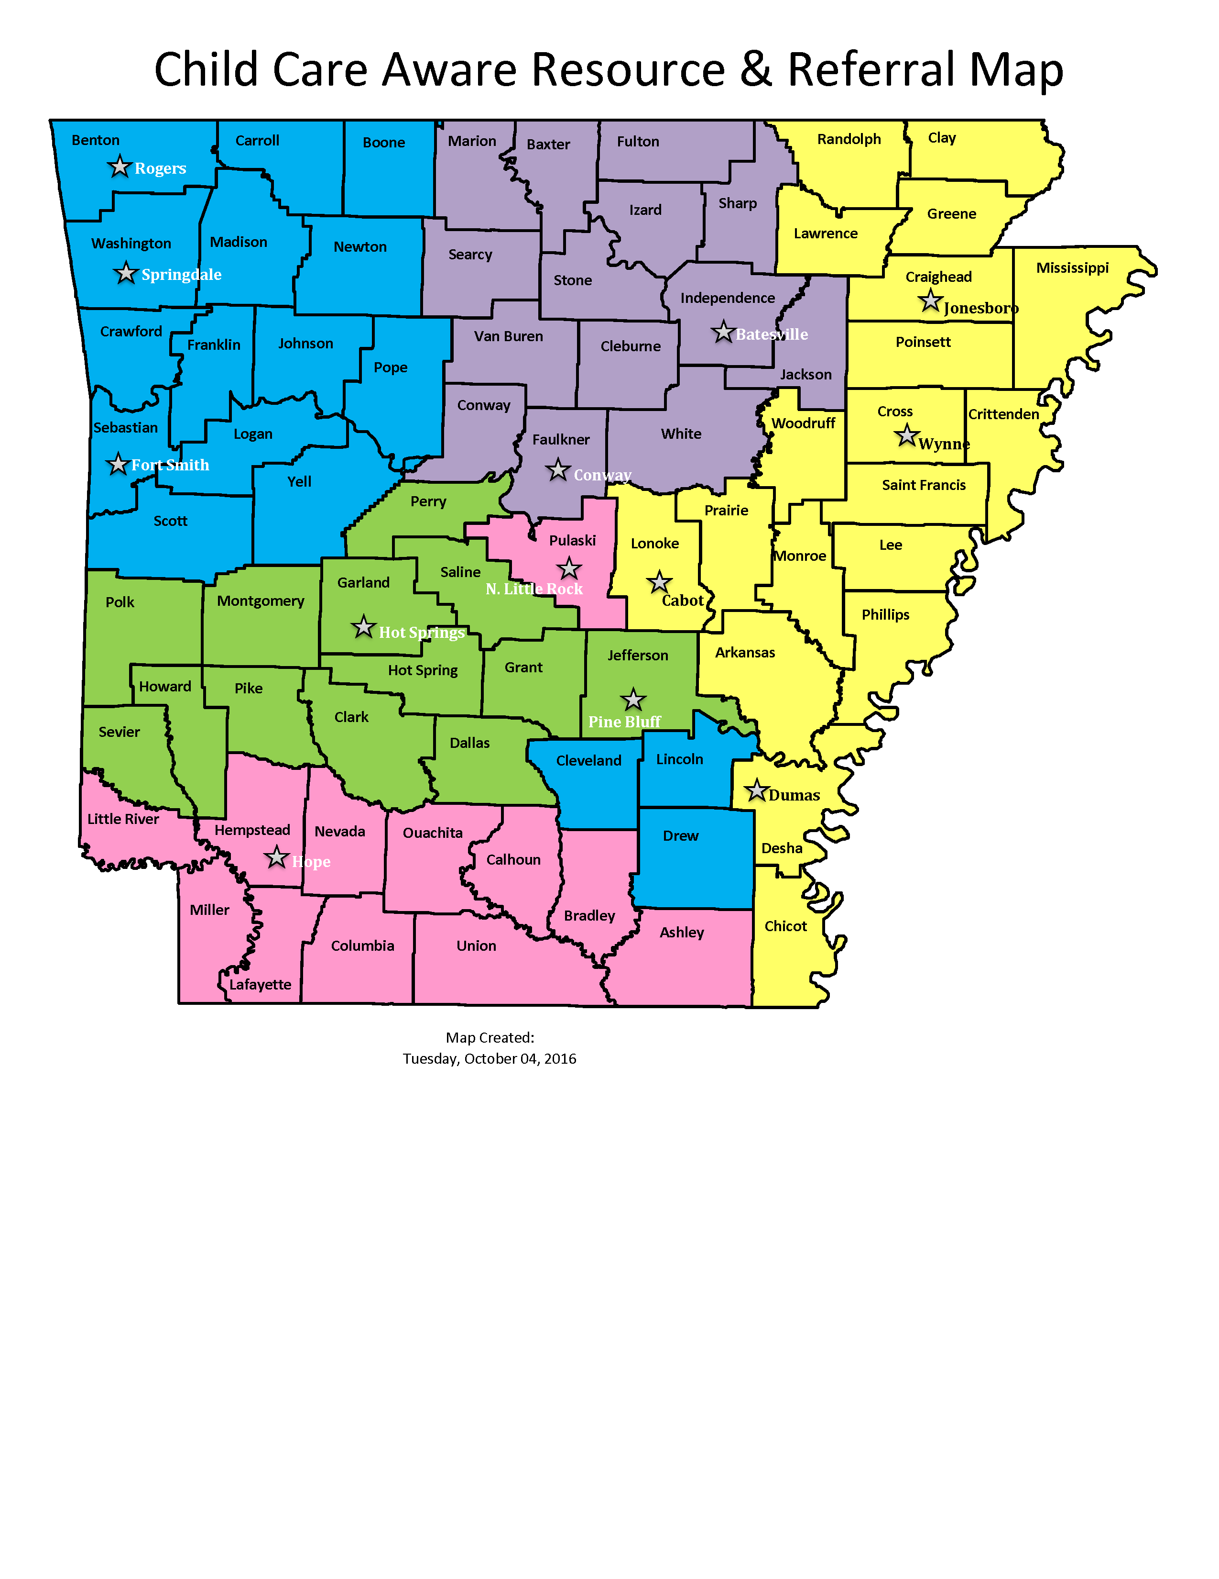

Bryant

Funded by the DHS Division of Child Care &
Early Childhood Education
State Contact: Paige Cox

Agency | Office Location | Contact | Email | Phone | Website
Child Care Aware of  Northwest Arkansas and River Valley | Springdale | Carolene Thornton  Director | cthornton@nwachildcare.org | 479-899-6374 | nwachildcare.org
 | Rogers | Michelle Wynn | mwynn@nwachildcare.org | 479-899-6374
 | Fort Smith | Erica Holland | eholland@nwachildcare.org | 479-222-6930
Child Care Aware of  Northcentral Arkansas | Batesville | Debbie Mize  Director | dmize@wrpdd.org | 800-737-2237 | CCANA.org
 | Conway | Carol Crockett | carolcrockett5@gmail.com | 501-327-6677
Child Care Aware of Eastern Arkansas | Jonesboro | Beverly Wright  Director | bwright@astate.edu | 870-972-3055 | chs.astate.edu
 | Cabot | Lyndsie Odle | lodle@astate.edu | 501-941-2880
 | Wynne/W. Memphis | Nicole Goad | jnwilson@astate.edu | 870-208-8832
 | Dumas | Sheri Godfrey | sgodfrey@astate.edu | 870-382-0200
Child Care Aware of Central and Southwest Arkansas | North Little Rock | Tiffani Fletcher  Director | tiffani.fletcher@childcareawarecswa.org | 501-374-0330 | Childcareaware  cswa.org
 | Hope | Dianna Stratton | dianna.stratton@childcareawarecswa.org | 870-474-5191
Child Care Aware of West Central Arkansas | Hot Springs | Terri Helms  Director | terri.helms@np.edu | 501-760-6588 | np.edu/childcare-aware
 | Pine Bluff | Jackie Riley | jacqueline.riley@np.edu | 501-463-1482
 | Bryant | Thomas Gage | thomas.gage@np.edu | 501-276-8565
Revised 03/31/22

